Walk 35 Ewyas Harold
Last walked in May 2018

Description. A 6 km (3 7 miles) gradual climb up and gentle walk downhill, across farmland and along minor roads.
Start. Ewyas Harold Explorer Map OL13 Grid 388286
Directions from Tesco’s roundabout. (Turn milometer to zero). Take the A465 to Abergavenny. At 9 7 miles you TR onto the B4348(B4347) for Ewyas Harold 1. At 10 5 miles TL for the Village Centre and park on side of road.

1. Ewyas Harold. The village is named after Harold, son of Ralph the Timid earl of Hereford, and great-grandson of King Æthelred the Unready, who was king of England in 978 ad. It lies on the site of Ewyas Harold Castle, of which only the motte remains. Continue along the road, passing by Temple Bar Inn, a Fish & Chip shop, the Dog Inn and the Village Store, you then cross over the Dulas Brook. 130m further on up the road you TL onto a footpath that goes up concrete steps and thru a small wooden gate towards Ewyas Harold Castle. Continue on wooden steps to go thru a kissing gate, and in front of you is the castle mound. The first castle on the site is believed to be one of the very few which were built before the Norman conquest under the Saxons, probably in 1048. Continue on up and around the L hand side of the castle mound, and onto concrete that leads you thru metal gates to a ruined farm building where you bear L. Just past a corrugated iron building on your R you go thru a metal gate and into F1. Continue along the L hand field edge, and at the field corner you TL to go thru a small metal gate into F2. Continue up the R field edge, to go thru a metal gate into F3 and continue up the R field edge to reach the field corner, where you go thru a metal gate into F4, (next to a mains electricity pole). Continue on in the same direction, the hedge is now on your L. Ignore any gates on your L as you walk up the L field edge and go thru a small metal gate in the field corner and into F5. Keep to the R field edge, and continue along the edge of the woods, to cross over a stile in the field corner into a copse. Continue in the same direction thru a small copse, keeping to the L of a wire fence. At the end of the small copse you reach the open field on your L F6. Bear half L and continue up the field to cut off the R hand corner of this field, and meet up with a metal gate at the hedge corner, (don’t go thru this gate).

2. Hedge corner. At the hedge corner you TR, keeping to the hedge on your R, to pass thru a metal gate into F7. Keep to the R field edge, and at the end of this field, you go thru a gate gap into F8, and go straight on across and thru a metal gate into a farmers yard. Go straight on across the farmers yard, keeping to the R hand side, (farm house is on the R). A short distance ahead you go thru a metal gate, and 20m further on you go thru another gate and into F9. TL, go straight across this field to cross over a stile into F10. Go half R across this field, heading towards a wooden mains electricity pole, to cross a stile onto a road. TR and walk along the road. TL at the first road junction going to Rowlestone and Walterstone. 120m further on you TL thru a small wooden gate and onto a public footpath.

3. Small wooden gate. Walk a short distance thru a lightly wooded area and into F11. Cut straight across F11 to reach the far R corner where you cross over a stile into F12. TL, keep to the L field edge. In the top L hand corner of this field you TL into F13, then immediately TR, and continue along the R field edge to reach the field corner and a gap in the hedges, (Wigga Farm is on your R hand side). Go thru a gate, thru a farm yard and thru another gate into F14 and TL. Walk along the L field edge, (following the hedge on your L) Cross over a double stile into F15. Bear half R and just past a small pond that’s in a ditch on your L hand side, you cross over three wooden planks and a stile, into F16. Go straight across this field, heading to the R of a wooden farm house (Cwm Barn) to go thru a metal gate into F17. Continue along the L field edge, and just past Cwm Barn you bear half R to cut off the field corner. In front of you are two metal gates going into separate fields, go thru the L gate and into F18, and walk along the R field edge. Go thru a metal gate into F19 and follow the L field edge for a short distance before heading of R towards a red roofed house in the corner of the field where you go thru a gate and onto a road. TR, Pass Old King Street farm on your R and ignore the No Thru road on your R as you walk on into Ewyas Harold

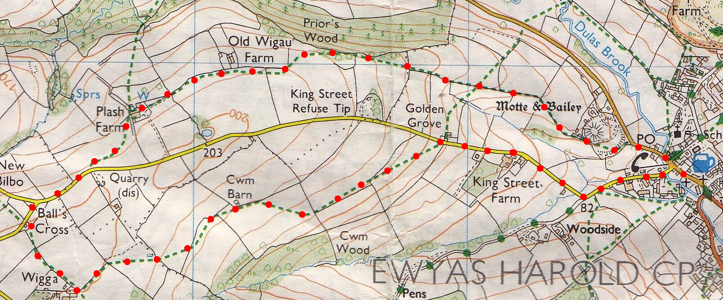
2
3
1

